Executive Summary

J/P Haitian Relief Organization is implementing a project entitled “Payment for Ecosystem Services (PES) to Protect Mangroves in Bondeau, Nippes, Haiti”. According to the project document, its general objective is to “protect mangrove ecosystems in Bondeau, Nippes, Haiti through concrete support to improve fishing and agricultural livelihoods, local capacity building, and a dynamic environmental stewardship campaign”. The project strategy is an integrated approach from ridge to reef to address climate risks, to improve farming techniques in Paillant which has a direct effect on the mangrove and fish population in the seaside. This approach assumes that with support to improve climate-adapted fishing and agricultural livelihoods, and the mobilization of youth in an environmental stewardship campaign, coastal mangroves in Bondeau that are critical to marine ecosystems and climate resilience will be protected.

The by the end of the project we expect the following outcomes:

1. Improved governance and natural resource management.
2. Local actors have taken on the role of environmental stewardship.
3. Livelihoods of fishers and farmers in Bondeau are improved by the end of the project.

This report presents the findings of the baseline evaluation for the project. The evaluation will be retaken at the end of the project to evidence the extent to which it creates the expected outcomes.

***Objective of the Evaluation***

The general objective of this study is to establish baseline data for the core outcome indicators that aim to capture behavioral changes that the project seeks to induce among its beneficiaries.

More specifically, the evaluation produced evidence that can guide the project implementation efforts to focus on the most critical areas where changes need to be induced. As the evaluation followed the KAP (Knowledge, Attitude and Practice) methodology, it produced baseline values for the following three sets of outcome indicators:

**Knowledge:**

* % of local governance stakeholders who demonstrated understanding of improved governance and management of natural resources.
* % of project beneficiaries (farmers, fishers, and school aged youths) demonstrated understanding of mangrove ecosystems protection practices

**Attitudes:**

* % of local governance stakeholders with positive attitudes towards improved governance and management of natural resources.
* % of project beneficiaries (farmers, fishers, and school aged youths) with positive attitudes towards mangrove ecosystems protection actions.

**Practices:**

* # of activities undertaken by local governance stakeholders towards improved management of Bandeau’s natural resources.
* # of community led mangrove protection activities carried out.

***Methodology***

The evaluation methodology is based on a qualitative and quantitative approach. By the qualitative approach we obtained qualitative information such as understanding of local authorities of problems related to managing Bondeau mangroves and their willingness to improve the governance and management of natural resources of the area. Thus, we only had in-depth interviews with local authorities in Focus Group Discussion. The quantitative approach focused on measuring knowledge, attitudes and practices of the targeted students, fishers and farmers about Bondeau mangroves, mountain soil management and environment protection. The survey was carried out using multi choice test questionnaires. The results of the tests related to knowledge attitudes and practices of the beneficiaries are be aggregated to report the core outcome indicators.

***Findings***

Knowledge

Attitudes

Practices

***Conclusions and Recommendations***

# Introduction and problem statement

J/P Haitian Relief Organization (J/P HRO) through the Haiti Take Roots (HTR) initiative will be implementing the project titled: Payment for Ecosystem Services (PES) to Protect Mangroves in Bondeau, Nippes, Haiti, for the next 24 months. Funded by Caribbean Biodiversity Fund in the context of the Ecosystem-Based Adaptation (EbA) Program, the project aims to “protect mangrove ecosystems in Bondeau, Nippes through concrete support to improve fishing and agricultural livelihoods, local capacity building, and a dynamic environmental stewardship campaign”.

More than 70% of the tropical coastline is covered by mangrove forests (Raven et al., 2009). In the Tropical and Subtropical region, mangrove forests are the equivalent of salt marshes. They are home for many species such as Pelicans, Herons, Crabs, Egret and so on. They serve as nurseries for different species thriving in the sea and feed them when needed. They are good nesting sites for birds. In addition, mangrove ecosystem play an important role in protecting coastline against erosion and inundation (MARIO et al. 2015). They help stabilize and protect the coastline against natural hazards such as Tsunami. Mangroves ecosystems help filtering water going down into the deep sea and stop the pollutants from going further. By providing food, materials, and protection to human through its numerous ecosystem services the importance of mangroves seems undeniable. However, its global coverage is seriously decreasing in the last decades.

Human activities such as farming in the adjacent mountain of watershed environments are among the most common factors that cause continuous degradation of downstream mangrove ecosystems. Adding to those factors, climate change is making things even worse. That is the situation of most mangrove ecosystems in Haiti where mangrove forests are destroyed for charcoal production, usage of wood as energy source, salt pans construction, beach and urbanization project, etc. The Bondeau mangroves is part of a watershed where the effects of bad use of land up stream combined with climate change effects are evident for decades. Due to uncontrolled erosion reducing soil productivity and causing continual decrease in harvests, the population of Surrounding Mountain of Bondeau move down to the sea level to find economic opportunities increasing pressure on the existing yet limited resources of the area. On the other hand, fishers are facing challenges as uncontrolled sedimentation chokes mangroves, changing the coastal ecosystem etc.

The most important factor to take into consideration in managing mountain lands is the human element. Therefore, many experiences have proven that “mechanical structures, reforestation, and other conservation practices will not achieve many benefits unless the inhabitants of these upland catchment areas are persuaded and given incentives to change from their present ecologically destructive practices such as shifting cultivation to more suitable land use” (Joshi, n.d.). Thus, the Payment for Ecosystems Services (PES) programs are incentive-based that compensate individuals or communities for undertaking actions that increase the provision of ecosystems services. Therefore, the PES to Protect Mangroves in Bondeau will articulate its intervention on an integrated approach from ridge to reef to address climate risks, in order to improve farming techniques in Paillant which has a direct effect on the mangrove and fish population in the seaside. This approach assumes that with support to improve climate-adapted fishing and agricultural livelihoods, and the mobilization of youth in an environmental stewardship campaign, coastal mangroves in Bondeau that are critical to marine ecosystems and climate resilience will be protected.

This document reports on the baseline evaluation conducted at the project launch. It provides baseline values for the project outcome indicators in such that we can verified its impact at the end of the project.

# project background and context

## BONDEAU WATERSHED Description

Localization, population, cultures(crops), topography, base of the local econmy, the local dynamic….

## Context

Due to continuous degradation of mangroves ecosystem etc….

## BONDeau PES Project framework and approach

Project approach.

## BONDeau PES Project theory of change (TOC)

The Bondeau mangroves are part of a watersheds with a complex ecological system where the impacts of a changing climate have already been felt for decades. Due to uncontrolled erosion reducing soil productivity and causing continual decrease in harvests, the population of Surrounding Mountain of Bondeau move down to the sea level to find economic opportunity increasing pressure on the existing yet limited resources of the area. On the other hand, fishers are facing challenges as uncontrolled sedimentation chokes mangroves, changing the coastal ecosystem etc.

J/P HRO’s participatory assessments in 2017-18 and workshops in May 2019 revealed that the community understands the importance of mangroves both as a refuge for aquatic species that are critical for fishing livelihoods and for protection during harsh weather. However, in the face of financial hardship, people living in Bondeau frequently use the mangroves as a source of supplemental income by cutting them to make charcoal.

Thus, the PES to Protect Mangroves in Bondeau will articulate its intervention on an integrated approach from ridge to reef to address climate risk, to improve farming techniques in Paillant which has a direct effect on the mangrove and fish population in the seaside. This approach assumes that with support to improve climate-adapted fishing and agricultural livelihoods, and the mobilization of youth in an environmental stewardship campaign, coastal mangroves in Bondeau that are critical to marine ecosystems and climate resilience will be protected.

## BONDeau PES Project activities

| Table 1: OUTCOMES, ASSOCIATED OUTPUTS AND ACTIVITIES | | |
| --- | --- | --- |
| Outcomes | OUTPUTS | MAIN ACTIVITIES |
| *SO1. Local actors have taken on the role of environmental stewardship* | *ER1.1 Stakeholders are mobilized and sensitized about natural resource management.*  *ER1.2 Stakeholders understand existing regulations and laws* | * Act.1.1.1 Identify key stakeholders for the project * Act 1.1.2 Sensitization/mobilization meeting with stakeholders * Act 1.1.3 Conduct baseline/Endline surveys * Act.1.1.4 Provide technical support/training to stakeholders * Act 1.2.1. Primer and training on relevant policies, laws & conventions * Act1.2.2 organization of workshops to educate local stakeholders |
| *SO2. Livelihoods of fishers and farmers in Bondeau are improved by the end of the project.* | ER.2.1 Young people become leaders in action for environmental protection.  ER2.2 A participatory protection and management plan is adopted for the Bondeau mangroves.  ER2.3 Ongoing public education changes the narrative about the environment  ER2.4 Improvement in socio-economic resilience of people exposed to the effects of climate change, due to EbA Facility interventions. | * Act 2.1.1 Establish environment clubs in schools * Act 2.1.2 Develop research projects in Paillant & Bondeau * Act 2.1.3 Students provide ongoing M&E through observation at sites * Act 2.1.4 Convene stakeholders to dialogue on best practices/lessons learned * Act 2.2.1 Hold conferences with working sessions to plan the development of protection & management plan. * Act 2.2.2 Realize participative workshops to elaborate the management plan for the Bondeau mangrove. * Act 2.2.3 Capacity building & accompaniment for key actors in plan. * Act 2.3.1 Develop regular meeting schedule & support collaboration among actors. * Act.2.4.1 Conduct Kwoledge,Aptitude and Practice survey (KAP) * Act.2.4.2 Conduct socio-economic Survey. |
| *SO3. Increased hygiene practices* | *ER3.1 Capacity of local fishers is strengthened*  *ER.3.2 Farmers benefit from supplemental income and sedimentation in mangroves is reduced* | * Act 3.1.1 Participatory assessment of existing fisher associations * Act 3.1.2. Establish cooperative of associations with shared goals & resources. * Act 3.1.3 Determine priority material resources and co- financing mechanism. * Act 3.1.4 Technical support/training & exchanges. * Act 3.2.1 Identify farmers or property owners on targeted lands. * Act 3.2.2 Provide trainings on nursery production and establish a tree nursery to produce moringa seedlings in Paillant. * Activity 3: Sign PES agreement, provide seedlings and PES until end of project. * Activity 4: Connect farmers to Acceso for sale of leaves * Act3.1.3 Provide continuous technical support. |

III. evaluation purposes, evaluation questions and evaluation use

….:

# evaluation design and rationale

nnnnn.

## Quantitative methods and approaches

### STudents, Farmers and FISHERS’ surveys

Describe survey methods, sampling strategy etc….

4.2. qualitative methods and approaches

### document review

…...

### key informant interviews

## data analysis

…..

## methodological limitations

…...

# Findings

## REspondents characteristics

….

### GENDER

Students

Percent student female 58.60%.

Percent student male 41.40%.

Total student  157

Fishers

Percent fisher female 4.55%.

Percent fisher male 95.45%.

Total fishers  44

Farmers

Percent farmers female 18.92%.

Percent famers male 80.18%.

Total farmers  111

Organize them in table

|  |  |  |  |
| --- | --- | --- | --- |
|  | Students | Fishers | Farmers |
| % Female | 58.60 | 4.55 | 18.92 |
| % Male | 41.40 | 95.45 | 80.18 |
| Total | 157 | 44 | 111 |

### AGE STRUCTURE

Text…..

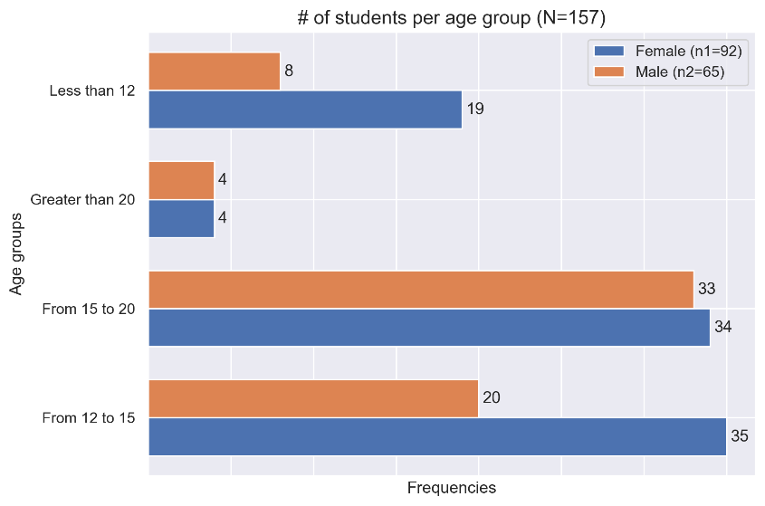

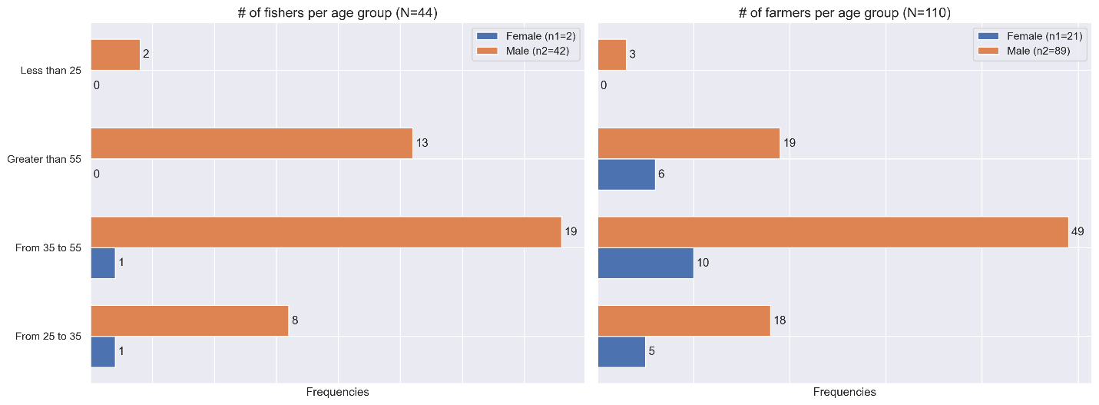

### Respondents Education Level

**Tex…**

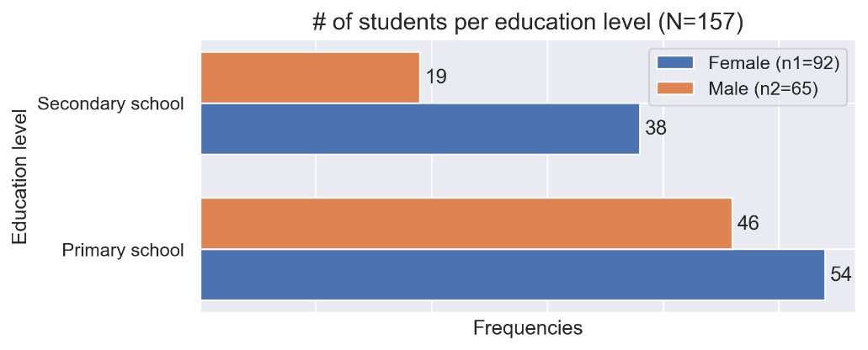

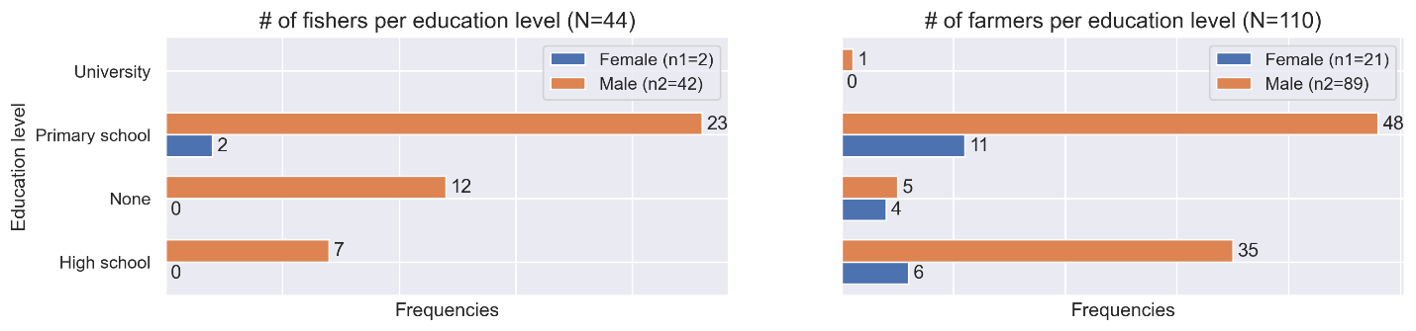

## **Evaluation Indicators**

### Knolwledge: what is level of understanding of repondents of climate change and environment management best practices?

* % of local governance stakeholders who demonstrated understanding of improved governance and management of natural resources.
* % of project beneficiaries (farmers, fishers, and school aged youths) demonstrated understanding of mangrove ecosystems protection practices.

|  |  |  |  |
| --- | --- | --- | --- |
|  | Male | Female | Total |
| % of students demonstrated understanding of mangrove ecosystems protection practices |  |  |  |
| % of farmers demonstrated understanding of mangrove ecosystems protection practices |  |  |  |
| % of fishers demonstrated understanding of mangrove ecosystems protection practices |  |  |  |

### Attitude: what are the respondents attitudes towards improved mangroves management and evironment protection?

* % of local governance stakeholders with positive attitudes towards improved governance and management of natural resources.
* % of project beneficiaries (farmers, fishers, and school aged youths) with positive attitudes towards mangrove ecosystems protection actions.

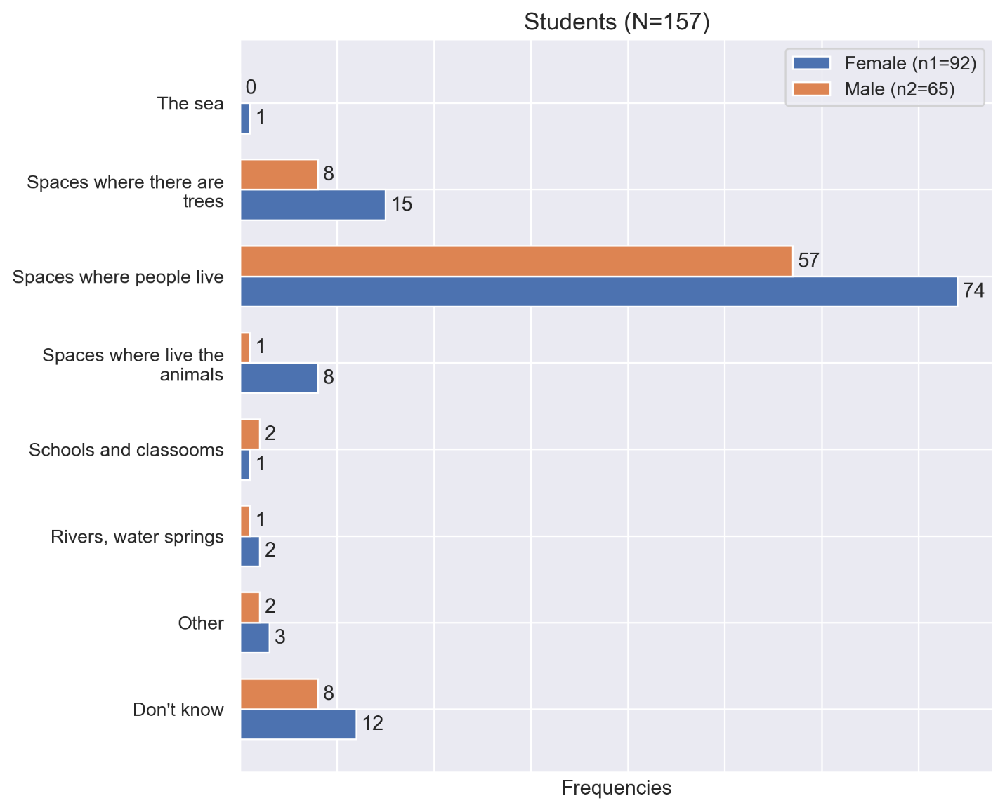

How should the environment be for us to be in good health?

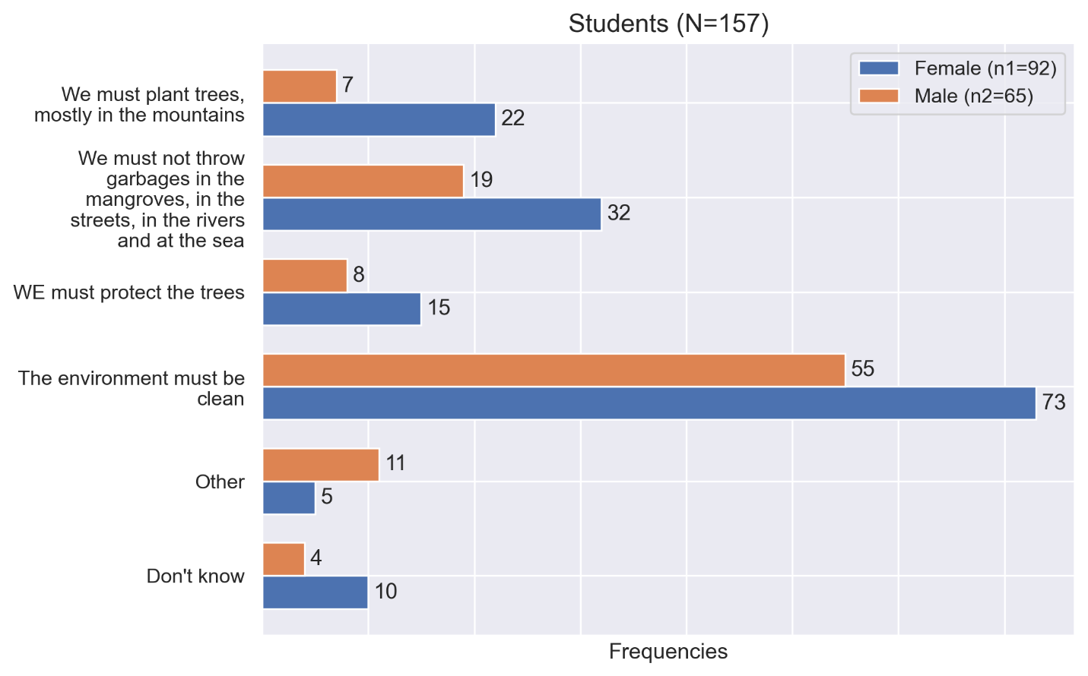

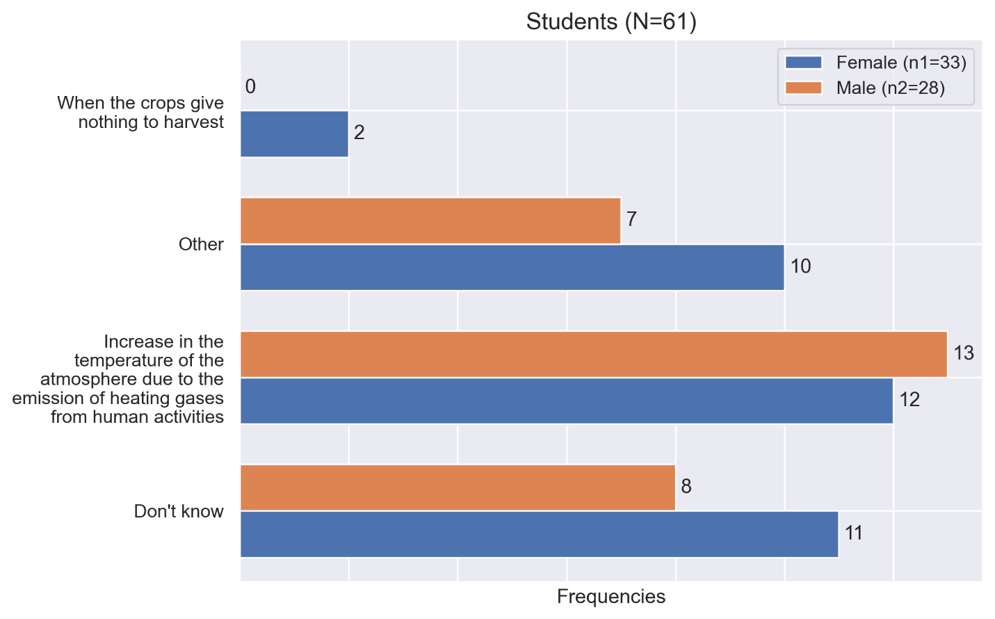

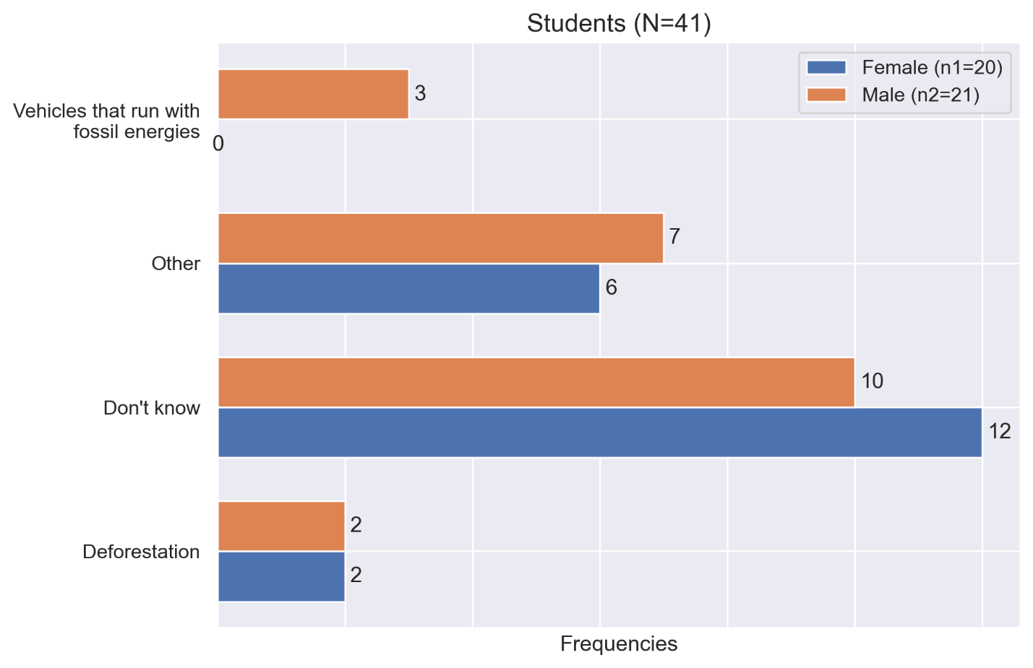

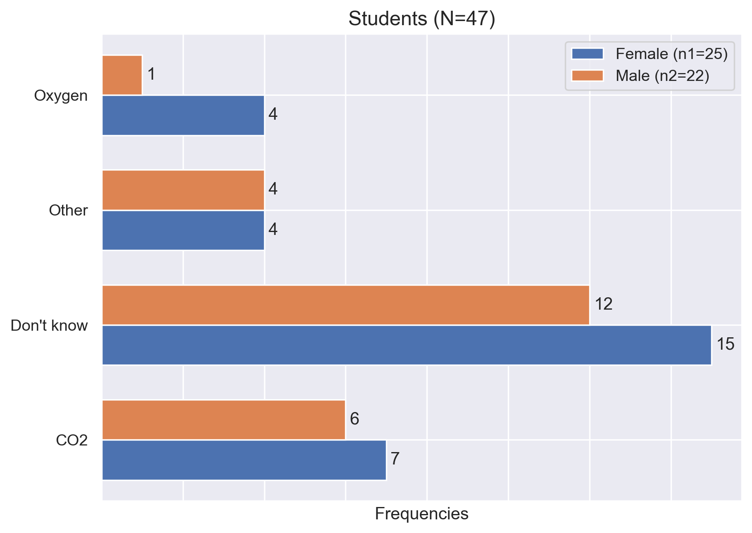

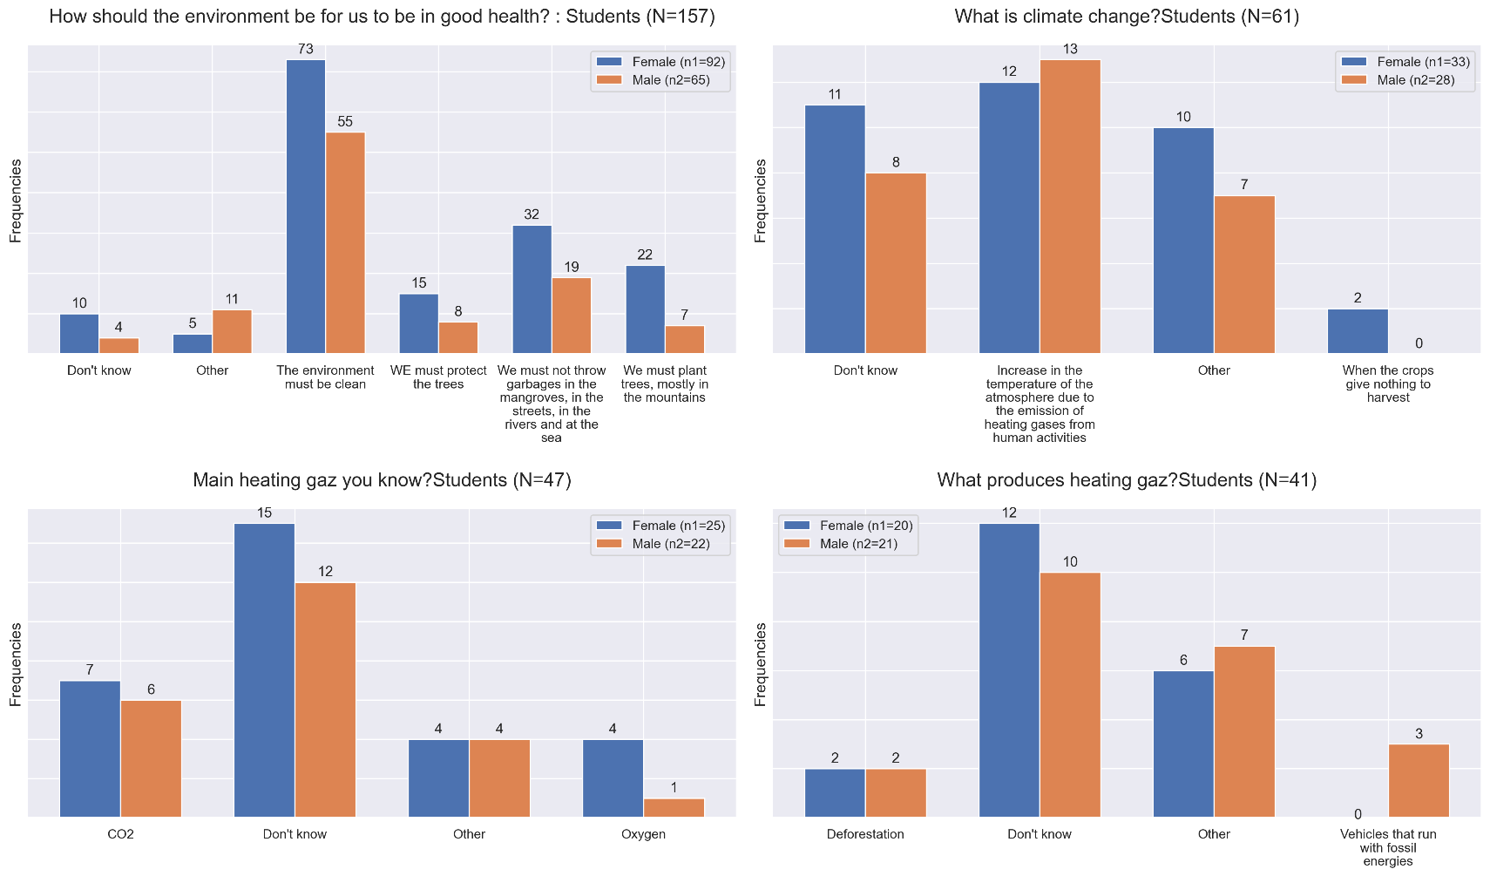

|  |  |  |  |
| --- | --- | --- | --- |
|  | Male | Female | Total |
| % of students with positive attitudes towards mangrove ecosystems protection actions. |  |  |  |
| % of farmers with positive attitudes towards mangrove ecosystems protection actions. |  |  |  |
| % of fishers with positive attitudes towards mangrove ecosystems protection actions. |  |  |  |

### practices: what are respondents doing to protect bondeau watershed natural ressources?

* # of activities undertaken by local governance stakeholders towards improved management of Bandeau’s natural resources.
* # of community led mangrove protection activities carried out.

# Conclusions and recommendations

# Annexes

SOW

Notebooks: data cleaning overview

KII notes.